If you are unable to access an existing/old PayPal account, follow the steps below to obtain and/or reset your credentials.

1. Click on “Forgot email or password”

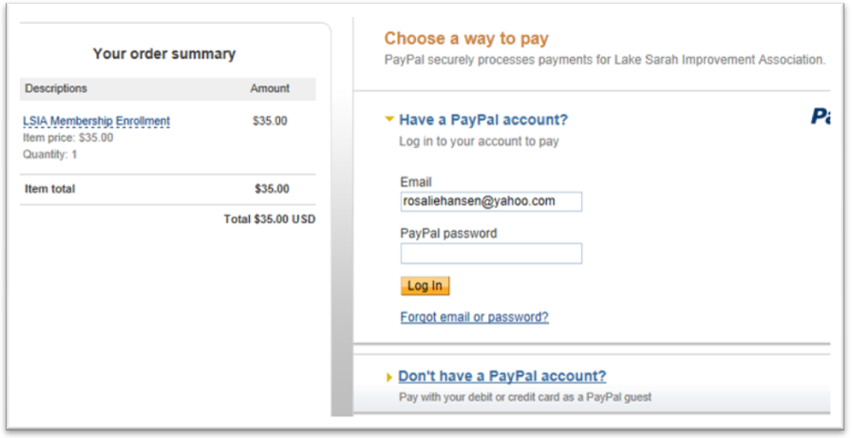

1. Select the appropriate option in relation to you situation.

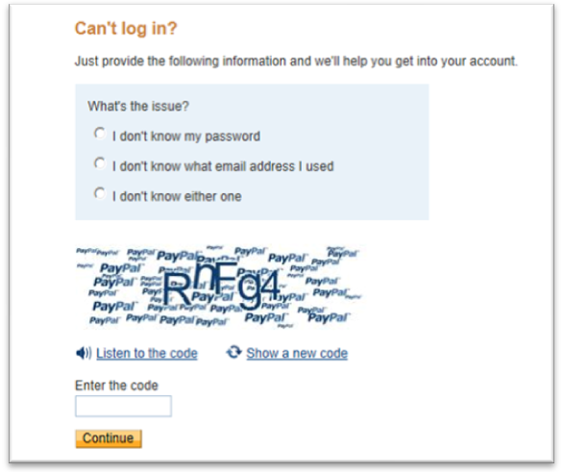

1. Enter the letter code.
2. Click “Continue”
3. An email will automatically be sent to your active account with your credentials within minutes.