Lake Sarah History: Shady Beach Inn, a Story Too Good to be Forgotten

By Dolores Ullstrom
A body of water can be a barrier that discourages communication between people who live on opposite shores. This point was brought home during a conversation I had recently with Richard and Eileen Klaers. The Klaers live on the south side of Lake Sarah on the farm where Richard was born. The farm has been in the Klaers family since it was purchased from Matt Schumaker by Richard’s grandfather in 1917. It was given to Richard’s father prior to his marriage. After reading about the first resort on the lake in the last edition of The Mouth of Lake Sarah, the Klaers asked if I was aware of the old Shady Beach Inn that still sits high on a hill, overlooking the lake on South Lake Sarah Drive. During my 22 years of living in the area, I had never heard about the Inn. I asked the Klaers if I could talk with them about the Inn and see it for myself. Eileen, wonderful hostess that she is, invited me to lunch.

When I walked into the Klaers’ home, I was surprised to see Florence Jacobs, a special lady whom I have long admired. Florence, 90 on her last birthday, told me that she had worked for many summers at Shady Beach Inn. Her name was Snodgrass then. Her two sisters, Lotty and Dorothy, had also worked at the Inn at various times. Their wages were in the $7 to $9 a week range. From Florence I go a picture postcard of the Inn and got permission to share it and her story.

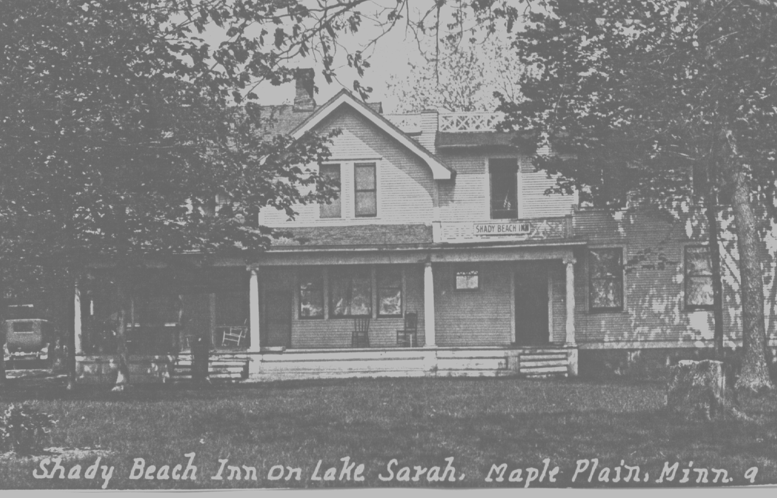

PICTURE: The original Shady Beach Inn

The Shady Beach Inn was a busy place before the Depression and World War II, before the days of good roads and dependable cars. Families would come to the resort and spend the whole summer living in the cabins. Fathers usually spent their week working in the Cities and would come out weekends to be with their wives and children. The Inn itself was mostly for singles, but it served as gathering place for meals and evening socials. From his farm, Richard remembers hearing the bell that called guests to meals.

Florence said that working at the Inn was a seven day a week job, from before breakfast to after the evening meal. The Inn was originally part of a farm. Cows on the farm produced cream for the Inn’s homemade butter and ice cream. Mrs. Anderson was the cook and, as Richard recalls, a very good one. In the 1929s Florence worked summers during her high school years and for a while after she started teaching. Depending on the number of guests, three to seven young girls were employed by the
Page 6
Andersons each summer to help with cleaning, waiting tables, and food preparation.

PICTURE: Florence Jacobs

Florence met her husband, Herbert Jacobs, while working at the Inn. Herbert farmed with his father west of the Inn on Highway 11. The Jacobs’ farm was purchased from the railroad by Herbert’s grandfahter soon after mustering out of the army during the Civil War. The cost of the land was approximately $2.25 per acre. The railroad owned land on both sides of Sarah. When the decision was made to lay tracks on the north side of the lake, land on the south side was put up for sale. The Jacobs’ farm is currently owned by Florence’s son, Richard. A historic sign on the property, visible from Highway 11, reads “Pleasant View Farm, 1864”.

After Mrs. Anderson, who liked to be well dressed, learned that Florence was a good seamstress, Florence spent a good deal of her time in one of the upper rooms of the Inn sewing for her. Mrs. Anderson had one dress style that she preferred, and she was fond of the color blue. Florence made the dresses look different by varying the trim.

Herbert Jacobs’ sister worked at the Inn with Florence. In the evening he would come to Shady Beach for swimming, or they would go to a show. Florence and Herbert were married June 3, 1930. Dorothy, Florence’s sister, married Herbert’s brother, Lawrence.

The resort business dwindled in the 30s, and the Andersons sold out. Mr. Anderson learned the electical trade and started Sig Anderson and Sons Electric in Maple Plain. The area was just beginning to be electrified. The Klaers’ farm was one of the first in the area to have electricity.

(Shady Beach Inn story continued)

The second floor of the Inn was removed late in the 1950s when it was owned by the Makousky family. It continued to be rented out for weddings and large parties. The building has been remodeled several times to reach its present spacious, open floor plan. The old Inn looks modern now. Tom and Jackie Emmer live in it with their five children. Jackie was kind enough to give me a tour. The only original room left intact is the main parlor, just inside the front door. The floor is made of maple, and there is a stone fireplace. Florence said that when they weren’t too tired after a day’s work, the girls would play the phonograph and dance on that maple floor.

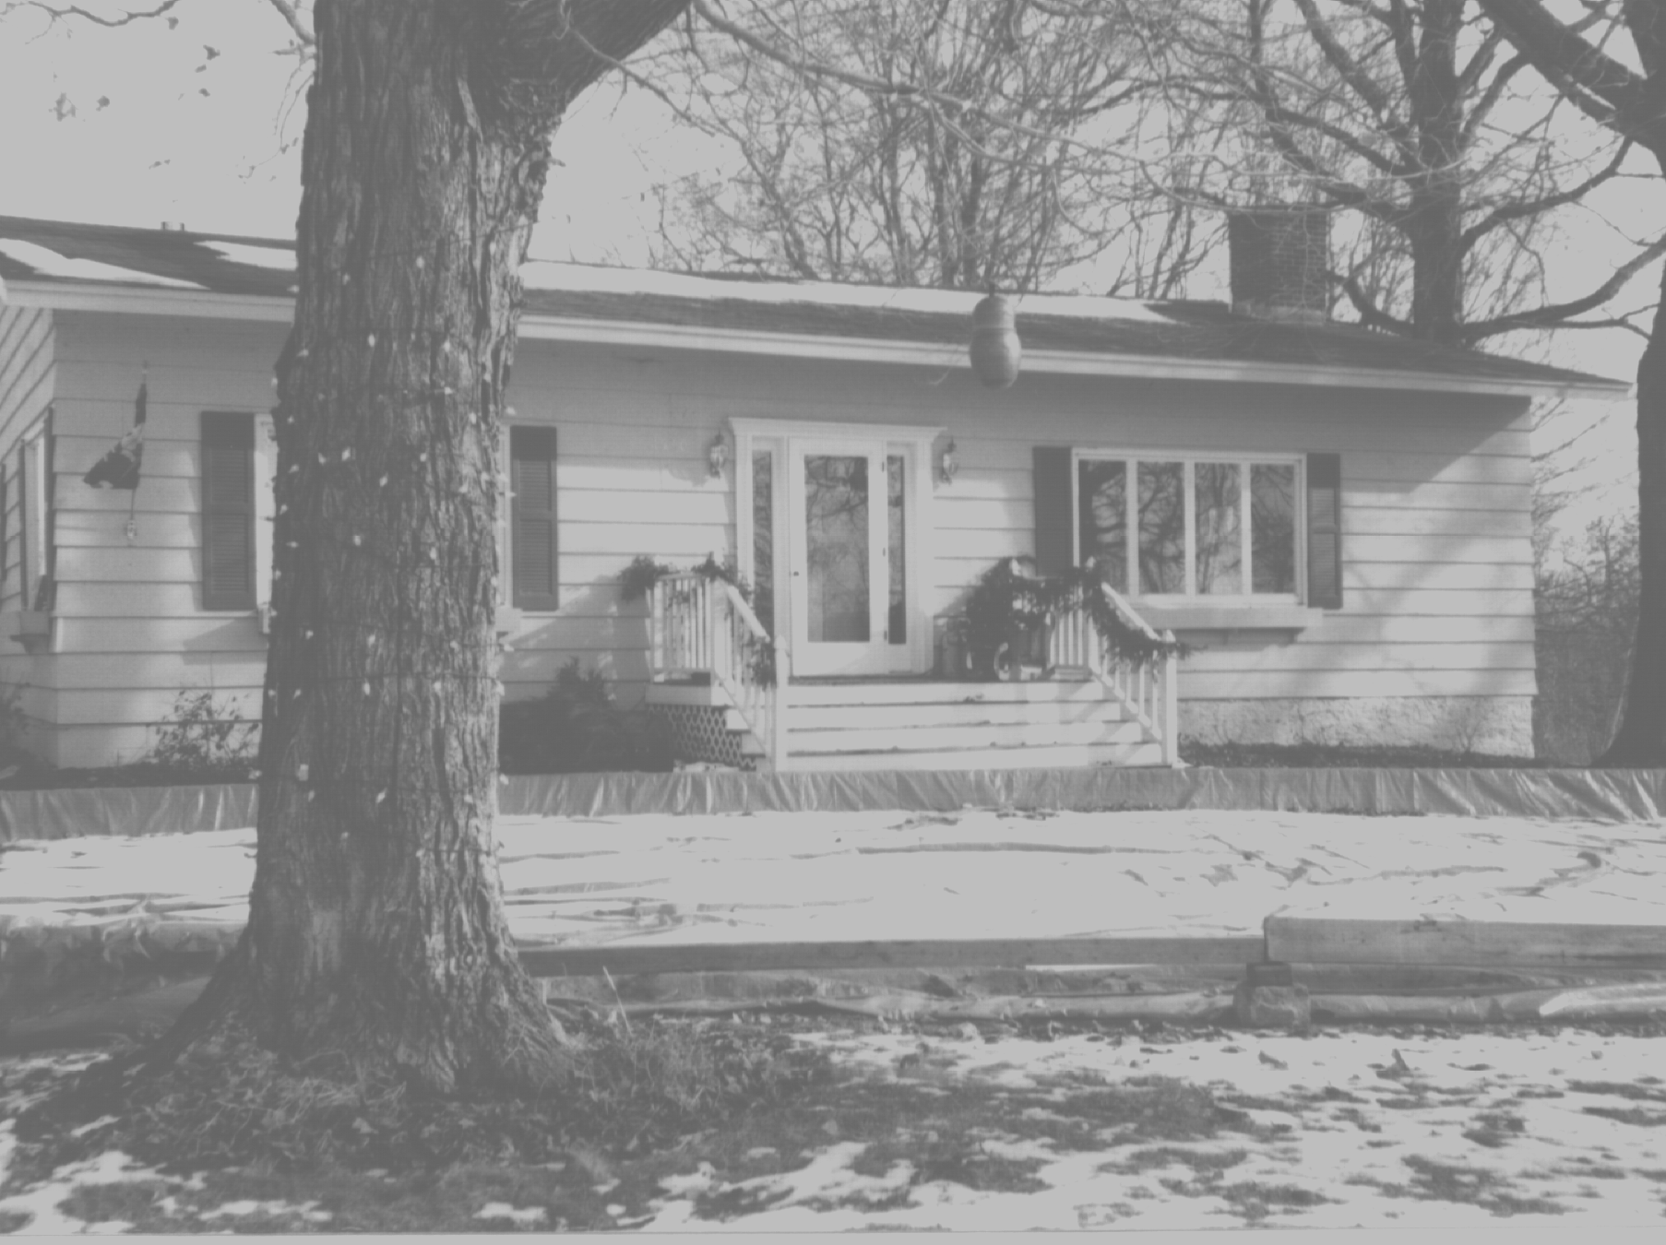

PICTURE: Shady Beach Inn, now home to Tom and Jackie Emmer

The Makouskys built a second story living area on a cabin down by the lake and sold the Inn, but retained the rest of the resort. The house the Makouskys lived in is currently owned by Schaun and Andrea Waste. It underwent major remodeling a year ago.

The Shady Beach Inn story and the story of the folks who lived and worked there are a part of Lake Sarah’s rich history. It is an American story of hard work, homemade ice cream, and long summer days. It was a time before air conditioning and PCs, when a dip in the lake was a simple, rewarding, and luxurious experience after a long, hard, humid work day. I am not sure I would want to return to those days even if I could.

But, they are fun to think about and much too precious to forget.

From the Mouth of Lake Sarah newsletter originally published April 1998

