Lake Sarah History: The Old Vander Hagen Place

By Dolores Ullstrom

See if you can follow my reasoning. The newly placed berms on Ron and Chris Lyrek’s property on the southeast end of Lake Sarah look a little like earthen dikes. Dikes remind me of Holland, and Holland reminds me of Henry and Marie Vander Hagen, former owners of the Lyrek property. Is that not a good excuse for another history lesson? Figuring that it is, Eileen Klaers and I headed for St. Therese Apartments in New Hope to visit with Marie Vander Hagen. Marie and Henry Vander Hagen moved from Independence in 1993. Henry passed away in 1994. Marie has health problems, but she has a good memory of family history and willingly shared it with us.

Photo: Marie Vander Hagen
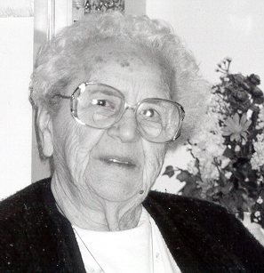

Henry Vander Hagen, born in 1903, emigrated to the US with his parents and 10 older brothers and sisters from Lith, Holland in 1905. Bernard, Henry’s father, had come to the US for several months the year before to scout the country for a place to settle. His sons were getting near draft age and he did not want them going into the military. His wife Marie was, for several good reasons, reluctant to leave Holland. Among those reasons were the travails of travelling with 11 children, leaving her homeland and family, and disruption of her comfortable, upper class urban life in Lith.

Bernard was persuaded to come to Minnesota by Father Van den Heuvel, the priest who built the present church in Loretto. Bernard was not a farmer but set out from Holland intent on farming. Bernard paid the passage of three men, farm hands who promised to work for one year in exchange for their passage. Two of these men were Gisbert Elsen (uncle of Al and John Elsen of Loretto) and Albert VanBeusekom (father of Ken and Adrian). Marie is not sure of the third man’s name.

Bernard had made arrangements to buy the Deisting place in Hamel. At Ellis Island he learned that Mrs. Deisting would not sign the papers. Father Van den Heuvel talked them into coming to Minnesota anyway. He put up most family members in the rectory and the older boys found other lodging until another farm could be found. The farm that the family purchased was located around the present site of Windmill Drive on the east end of the lake. A year or so later the Schumacher’s farm, site of the present Lyrek home, was up for sale. The Vander Hagens bought it and moved the family into the almost new 5 bedroom house. The oldest son, Bernard, Jr., stayed on the original farm. Bernard Sr., not being a farmer, went to the University of Minnesota to get information on farming in Minnesota. Thus began a life long family connection with the U of M and the Extension Program.

The newly purchased farm was a lovely piece of ground, with lake shore on both Independence and Sarah. Like so many others on Lake Sarah, the family rented boats to fishermen. Records show that the railroad sold the land during the Civil War (1864) to John and Rosa Lock. It was later sold to John and Marie Gaspar and then to a line of Schumachers, Joseph and Mary, Matt, and then Peter and Magdalena, from whom Bernard and Marie Vander Hagen purchased the land in 1905. In 1936 the title was transferred to son Henry and his wife Marie. The farm was later split up. Henry and Marie used part of it, on the south side of Cty 11, to build a new home. They moved into that home in 1955. Vinland Center sits on land that was once part of the original farm.

Photo: Former Vander Hagen home, now owned by Chris and Ron Lyrek
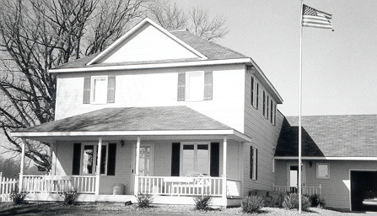

Between 1955 and 1988 the former Vander Hagen home on the north side of Cty 11 was rented out. It was a duplex for a while. The man who bought the farm from Henry and Marie about 1988 tore down the barn, sold the weathered boards, and began remodeling the house. He was unable to complete the project. The house sat vacant for a few years until Ron Lyrek bought it about 9 years ago. Ron and Chris have completely remodeled the house, and it is lovely.

Photo: Chris Lyrek and their children

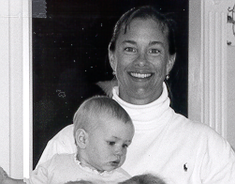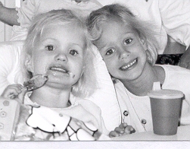

Newly arrived emigrants from Holland often stayed at the Vander Hagen farm until they had their own place. Marie’s father, Tony Adams, and two cousins built the Vander Hagen barn with plans from the U of M. Thus started a friendship that eventually resulted in Henry and Marie’s marriage October 24, 1928 at Holy Name Church. She was 20 and he was 25. They immediately moved into the farmhouse. Barnard Sr and his wife Marie moved out the next day and went to Minneapolis to live. Marie, the younger, was a busy young housewife. She and Henry had two children, and there were always hired men to feed.

Education was important to both the Vander Hagens and the Adams. Some of Bernard Vander Hagen Sr’s children went to St. Mary’s in Winona for high school and the U of M for college. In Holland all the older children had gone to boarding school. Before Loretto and Delano merged, Loretto families had to drive their children to high school in Delano. Marie went to elementary school for one year at Ascension in Minneapolis. About 5 a.m. on Monday morning at the Hamel station, Marie boarded the train to Minneapolis and rode into the city, where she transferred to a streetcar that took her to Ascension. She stayed with an aunt during the week, coming home to Hamel on Friday nights. This was thought to be easier than walking 2.5 miles every day to Holy Name School.

Henry and Marie were life long volunteers. Henry was on the Delano/Loretto School Board for many years. Marie was a 4-H leader for 27 years. For 17 years they sang with the North Hennepin Community Choir that entertained all over the county. They spearheaded the formation of the Delano and Loretto Senior Citizen Groups. In 1980 Henry and Marie were honored for their volunteerism by being named Hennepin County’s Volunteers of the Year.
It was such a pleasure to meet with Marie and hear her stories. I want to thank Eileen for making the arrangements and accompanying me. Every time I pass the old modernized farmhouse, I will think of its rich history, happy that it has a new lease on life.

