
Did the Shady Beach Bell kill Mrs. Lamont?
(Lake Sarah version of course!)

When I first moved into the area and began researching the history of the Anderson Inn / Shady Beach Resort, numerous sources recounted the story of how the old Anderson Inn bell had killed Mrs. Lamont by falling upon her from it’s mount sometime in the 40’s or 50’s. The stories varied somewhat but the common theme said the bell fell on her and broke her leg, the resulting injury left her in such a fragile state that she then died less than a year after the accident.
Having acquired the old bell from the Johnston family when they moved to Maple Plain (their former home now belongs to Ann Slavec) I naturally began to wonder if this “killer bell” had truly harmed anyone! Several years after obtaining the bell, lake neighbors Bob and Mona Meehan offered to introduce me to a friend of theirs, Ron LaMotte who’s grandparents had owned the Shady Beach Resort in the 1950’s.
Our first correction was of course her name, not Mrs.Lamont, she was Susan LaMotte!

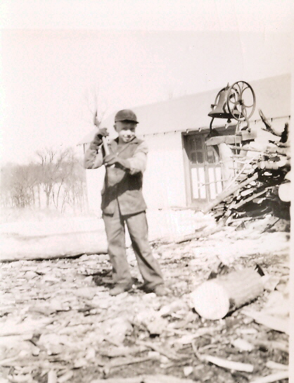
Ron next to the Shady Beach bell in 1946 Ron LaMotte in 2008 with the bell in its current home in the Spencer hillside

Ron LaMotte returned to lake Sarah for a short visit in 2008 during which time he allowed an interview, recounting the memories of the summers of his youth, growing up and working with his grandparents at the old resort from age 6 until he was about 16. The photo (above left) shows a young Ron LaMotte next to the Shady Beach bell. Ron’s mother Frances estimated that he would have been about 10 at the time. Notice the bell was mounted to a tree stump and still possessed its rope wheel. In those days the bell was used primarily by Susan LaMotte to call her husband Henry LaMotte up from the lower resort building, campgrounds or cabins for his meals or other tasks. According to Ron, the bell did indeed fall from its mount sometime in 1957 prior to the sale of the resort to Milton (Mac) Makousky. The heavy old steel bell broke his grandmothers foot or ankle and from then on she walked with the help of a cane. She passed away about 2 years later in 1959 of a heat attack while living in Aitkin County.
Conclusion - Yes, the bell did fall and seriously injure Susan LaMotte
It was not, however, the ultimate cause of her death!

Watch for the rest of our interview with Ron along with his photos of the old Inn from the 50’s with its fireplace and taproom where many locals celebrated the milestones in their lives. The article will be posted to the History page on lakesarah.com when it is completed!

